**Lesson 03 Demo 02**

**Creating a Video Using AI**



Steps to be followed:

1. Generate a video for a scenario using InVideo

| **Disclaimer:** Please note that the GenAI tool used in this exercise can produce varied outputs even when presented with similar prompts. Thus, you may get different outputs for the same prompt. |
| --- |

**Step 1: Generate a video for a scenario using InVideo**

1. Navigate to the <https://ai.invideo.io> website

1. Add the desired prompt  
     
   A screenshot of a computer

   Description automatically generated
2. Select the workflow as desired  
     
   A screenshot of a computer

   Description automatically generated

| **Note:** Keep the default option if you don’t want to select any workflow |
| --- |

1. Click on the **Generate a video** button  
     
   A screenshot of a computer

   Description automatically generated
2. Select the desired options for **Audience**, **Look and Feel**, and **Platform** as shown in the screenshot and click on the **Continue** button:  
     
   A screenshot of a computer

   Description automatically generated

It takes up to 2 minutes to generate the video.

1. Click on the **Export** dropdown, and then select the **Export video** option  
     
   **A screenshot of a video

   Description automatically generated**
2. Select the options as shown in the screenshot below and then click on the **Continue** button:  
     
   A screenshot of a computer

   Description automatically generated
3. Click on the **Download** button to save the video  
     
   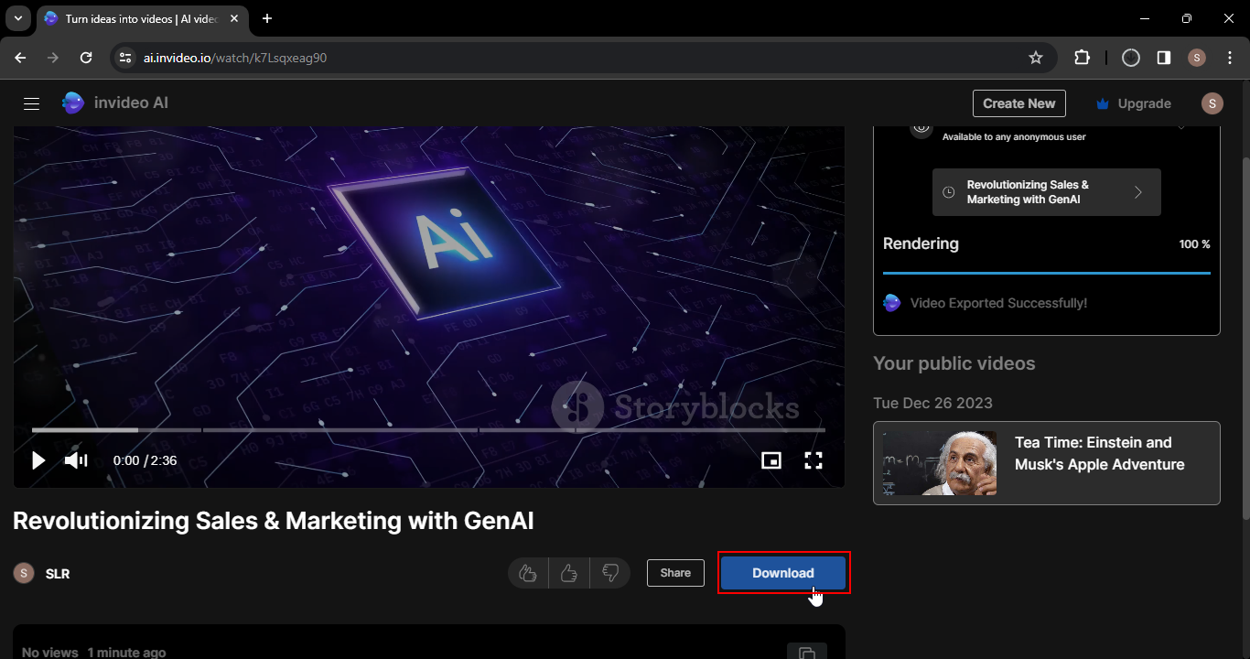  
     
   By following these steps, you have successfully created a video and demonstrated the effective use of InVideo for crafting dynamic and engaging videos, customized to specific preferences and settings.